**1 INTRODUCTION**

* 1. Overview
* Select a template. Browse different styles and themes of certificate designs for your needs.
* Add more design elements.
* Personalize your design.
* Order your prints.
  1. Purpose
* To recognize the participants,winners,and contributors of a debate competition.
* Designing beautiful creative assets easy for everyone.
* Students can create,collaborate,and communicate visually in the classroom.
* Include essential information.

1. **Problem Definition & Design Thinking**
   1. Empathy Map

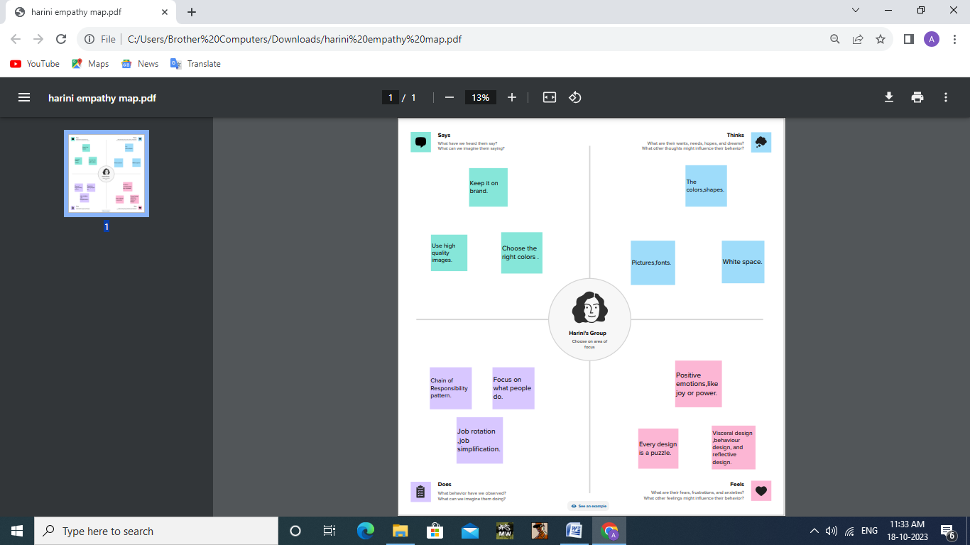

* 1. Brainstorm

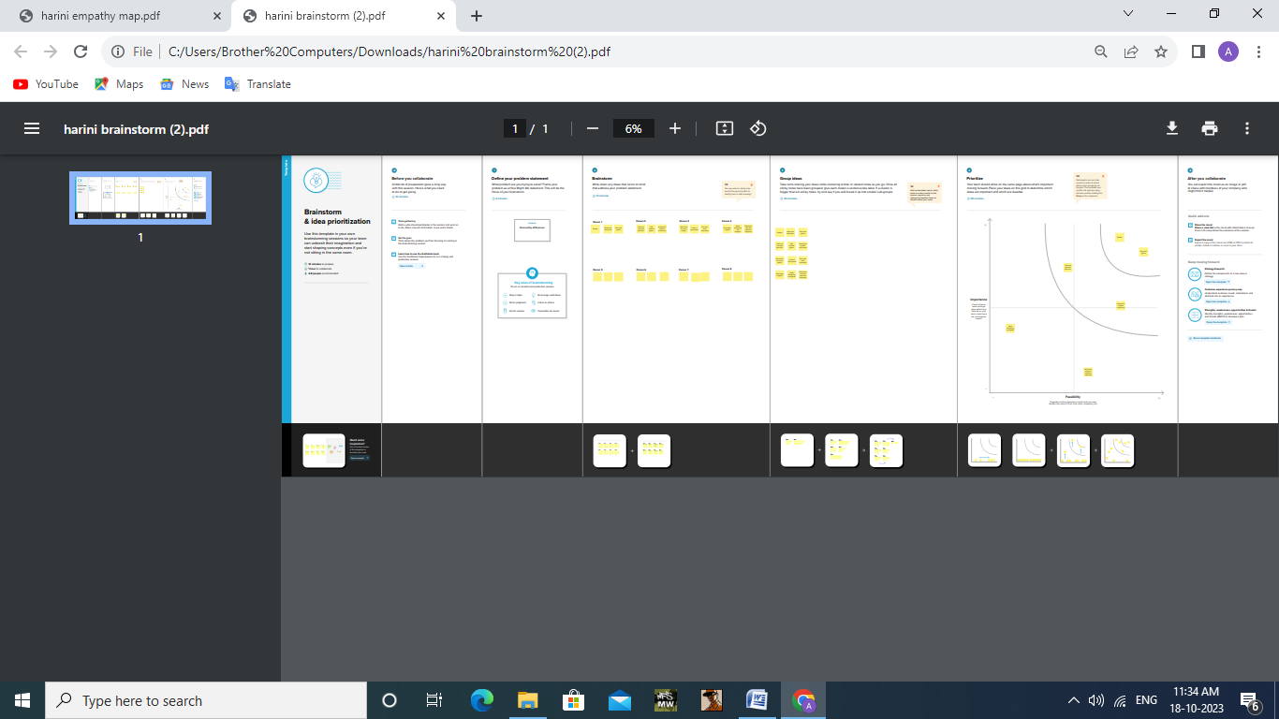

1. **RESULT**

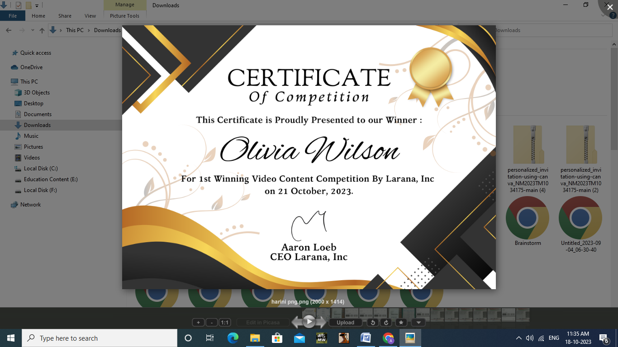

**4 ADVANTAGES & DISADVANTAGES**

Advantages:

* Canva provides social media templates.
* Templatescan be altered to be more custom.
* Even a non-designer can become a designer using canva.

Disadvantages

* It is time consuming to go through the lengthy process before the realisation.
* It isles economical since one requires stationery and quite a lot of materials to present the various stages.

1. **APPLICATION**

With canva’s wide selection of templates and easy-to-use drag and drop certificate generator,you can come up with the certificate you need in minutes,no design experience needed. Add high-quality images and illustrations,choose from over a hundred fonts and customize colors in a few clicks.

1. **CONCLUSION**

Canva is an excellent design app and arguably one of the most useful tools a small business can have in its arsenal.It lets you create an astonishingly large range of assests including adverts, infographics,videos and even websites-easily, cheaply and quickly.